Device to Cloud

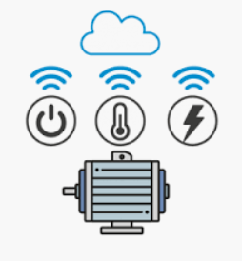

What to do?

Create Device Simulator to send telemetry data to Azure IoT Hub

Azure IoT Hub

device

back-end

application

Open Visual Studio / Create C# Console App .NET Core / Name = c2d

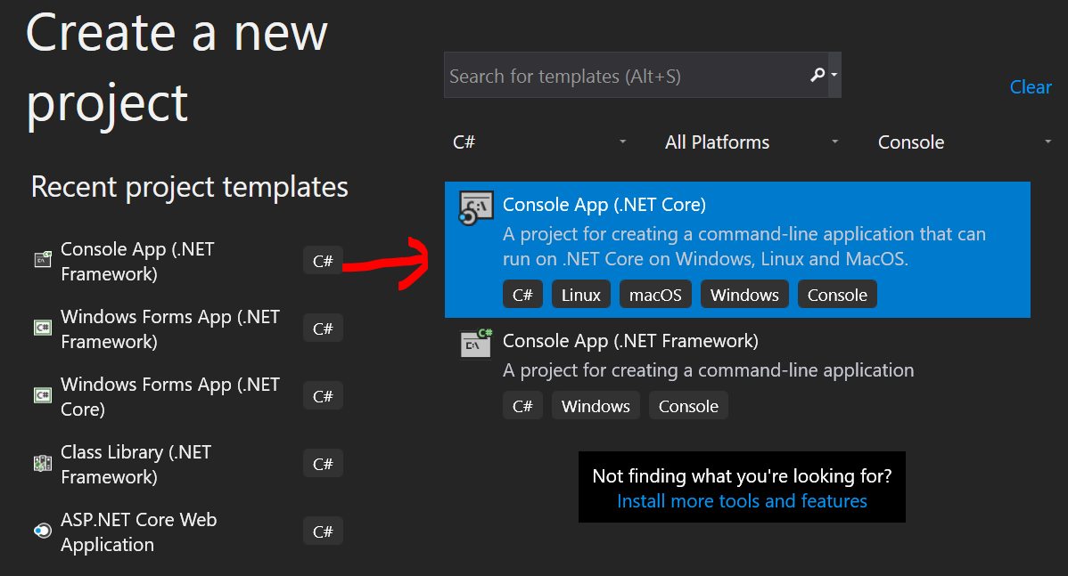

NuGet 2 packages

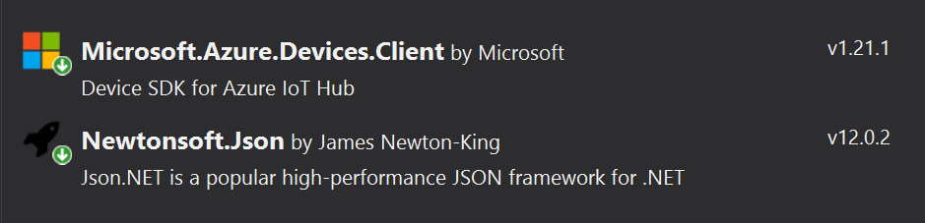

Add name space

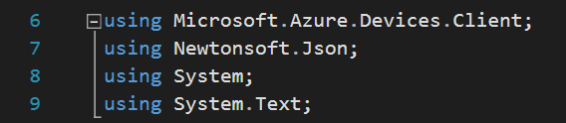

Add 2 Class fields



Add method SendDeviceToCloudMessagesAsync()

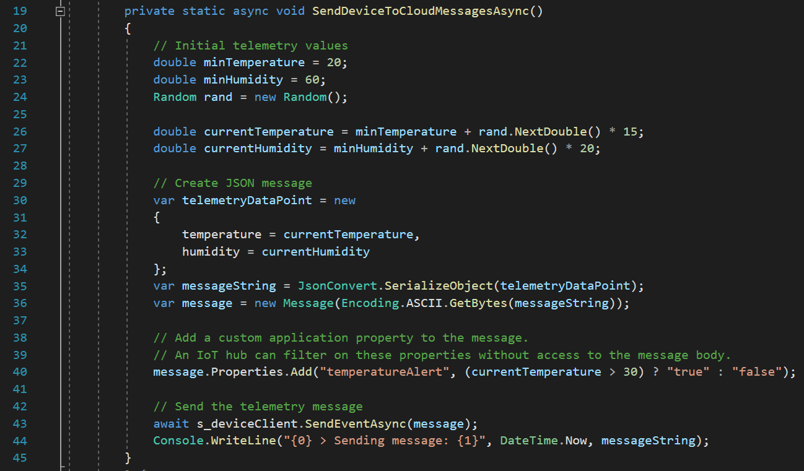

Add code to Main

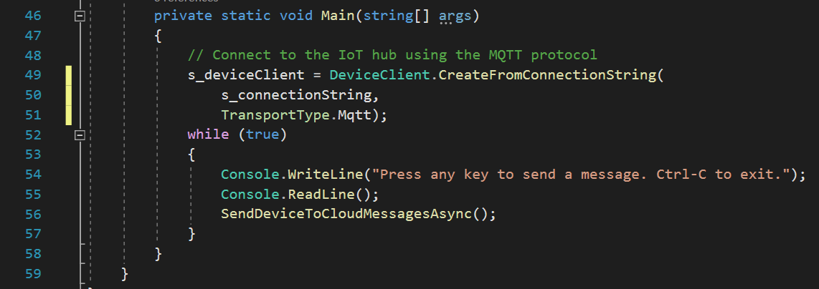

Azure IoT Hub Device Explorer

The device explorer is a tool uses the Azure IoT service libraries to perform various functions on IoT Hub.

* Create a new device
* Delete a device
* Monitor data from device
* Send back-end message to device

Azure IoT Hub

device

back-end

application

Download and setup Device Explorer

To view telemetry data you need a back-end application

Download link

https://github.com/Azure/azure-iot-sdk-csharp/releases/tag/2019-1-4

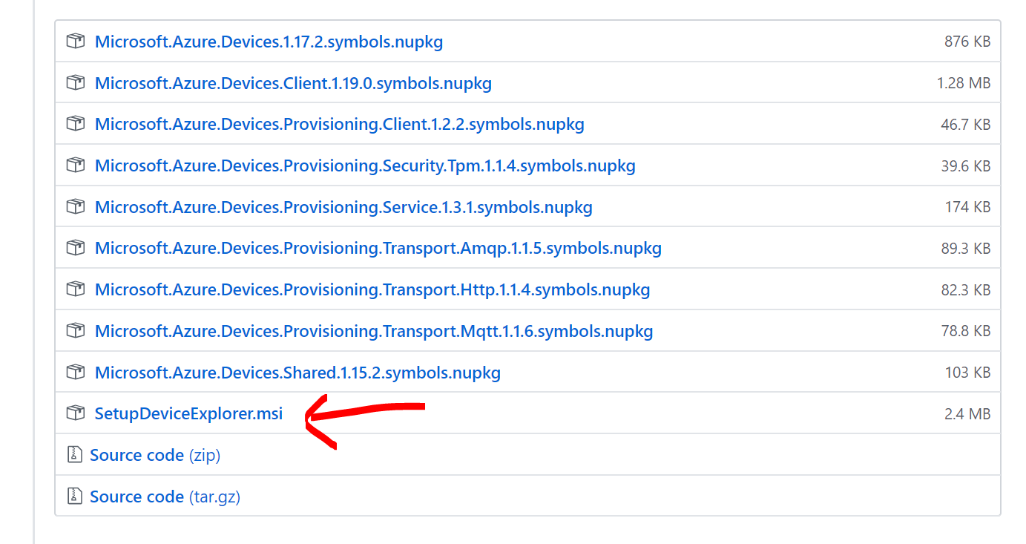

Configuration using IoT Hub Connection String

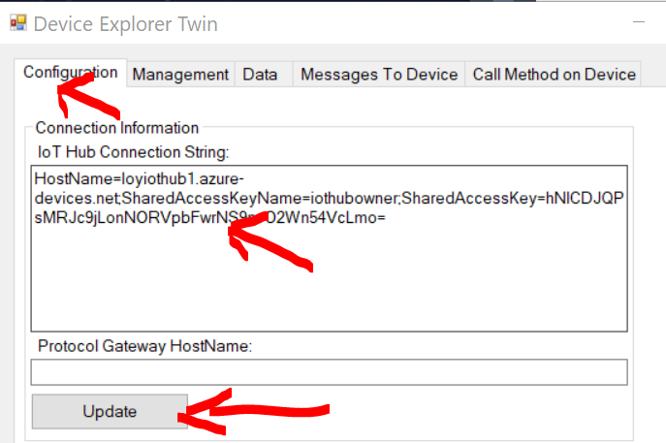

Send Device to Could message and monitor using Device Explorer

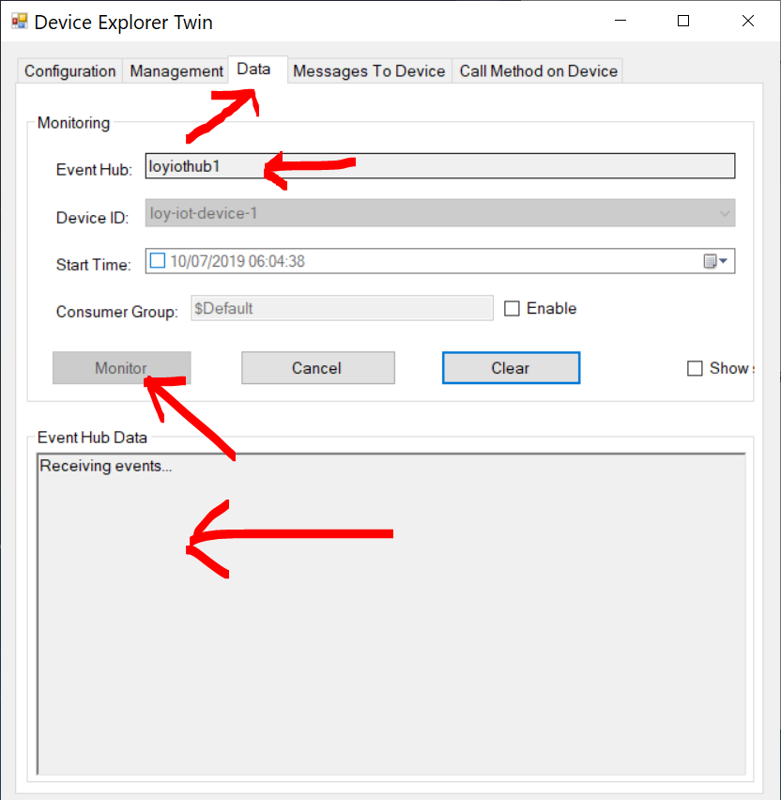

What's next?

